Supplementary Materials for

Ultimate 0.34 nm Gate-length Side-Wall Transistors with Atomic Level Channel

Fan Wu, Yang Shen, He Tian, Jie Ren, Guangyang Gou, Yi Yang and Tian-Ling Ren

Correspondence author. Email: RenTL@tsinghua.edu.cn; tianhe88@tsinghua.edu.cn

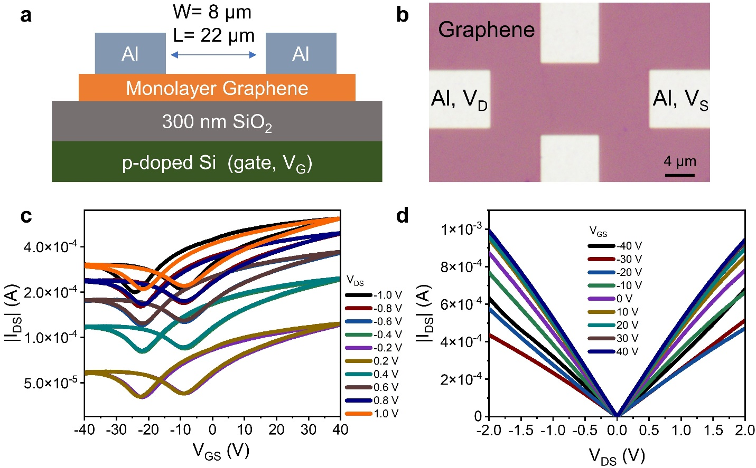

Fig. S1. The electrical characteristic of back-gate graphene transistors. (a) The back-gate structure of graphene transistors. The channel width and length are 8 μm and 22 μm, respectively. (b) The optical image of the back-gate graphene transistor. After Al deposition, the samples are stored at 10-5 mbar vacuum to avoid oxidization. (c)&(d) The *I*DS-*V*GS transfer and *I*DS-*V*DS output curves. The electrical conductivity is ~106 S/m at *V*GS=0 V.

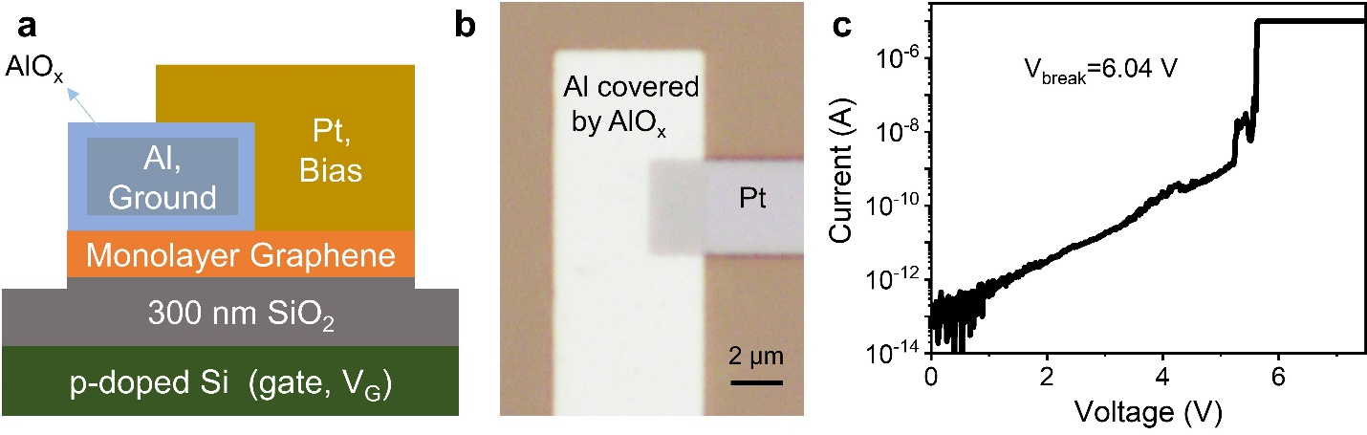

Fig. S2. The quality of self-oxidized AlOx. (a) The test structure. After Al deposited on graphene, the samples are stored in clean atmosphere condition for more than 3 days. Then, Al is surrounded by dense AlOx layer. (b) The optical image. (c) The *I*-*V* breakdown curve. The break down voltage is around 6.0 V.

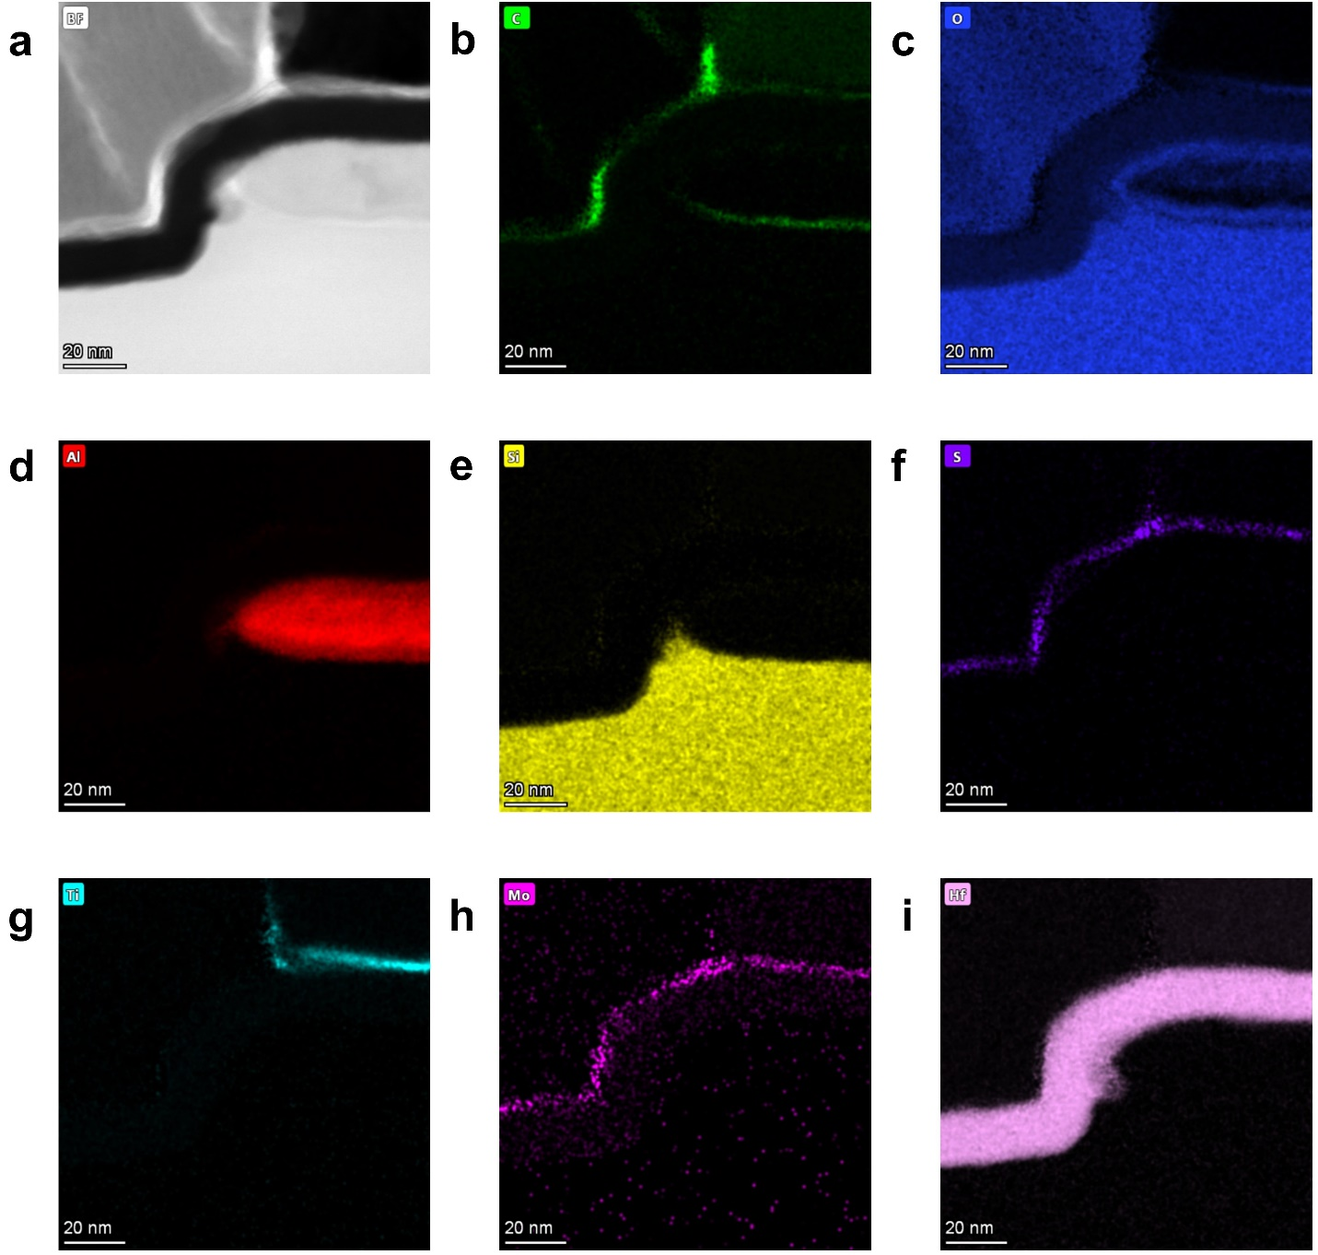

Fig. S3. The EDS mapping of the core region in this 0.34 nm gate-length side-wall MoS2 transistor. (a) The TEM image of this EDS mapping region in BF mode. (b-i) The EDS mapping of carbon, oxygen, aluminum, silicon, sulfur, titanium, molybdenum and hafnium. The mapping of aluminum and oxygen confirms that Al is surrounded by ~5 nm dense AlOx layer. The mapping of molybdenum and sulfur verifies presence of the 2D MoS2. Carbon seen on the top of HfO2 can be attributed to the organic residue like PMMA or contaminants from fabrication.

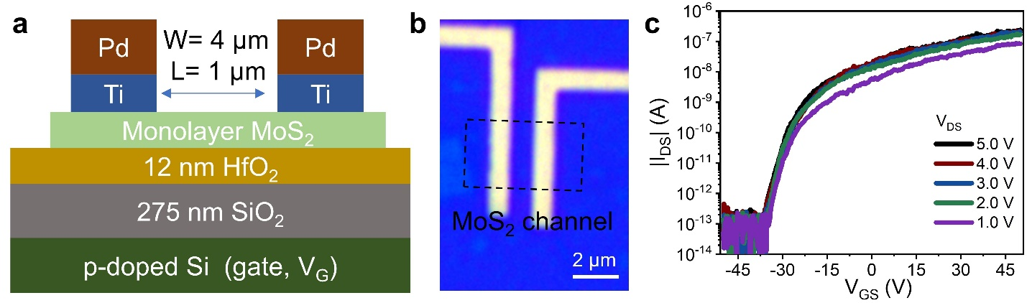

**Fig. S4. The electrical characteristic of a back-gated MoS2 transistor.** (a) The test structure. The channel width and length are 4 µm and 1 µm, respectively. (b) The optical image, MoS2 is patterned before metal deposition. (c) The *I*DS-*V*GS transfer curves. The channel is highly n-doped when *V*GS=50 V.

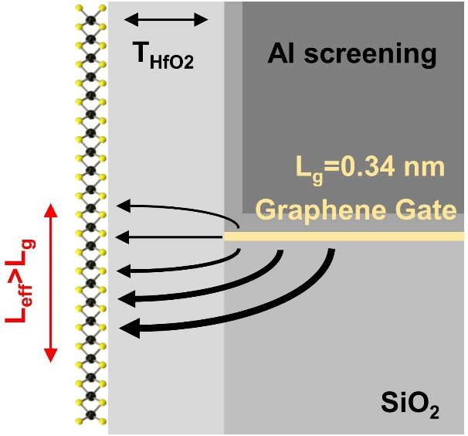

**Fig. S5. The effective MoS2 channel along side-wall that impact by graphene gate.** The electrical field from the upper surface of graphene gate can be screened by Al layer, thus the electrical field is not symmetry. The 2D planar characteristic of graphene provides stronger gate control ability.

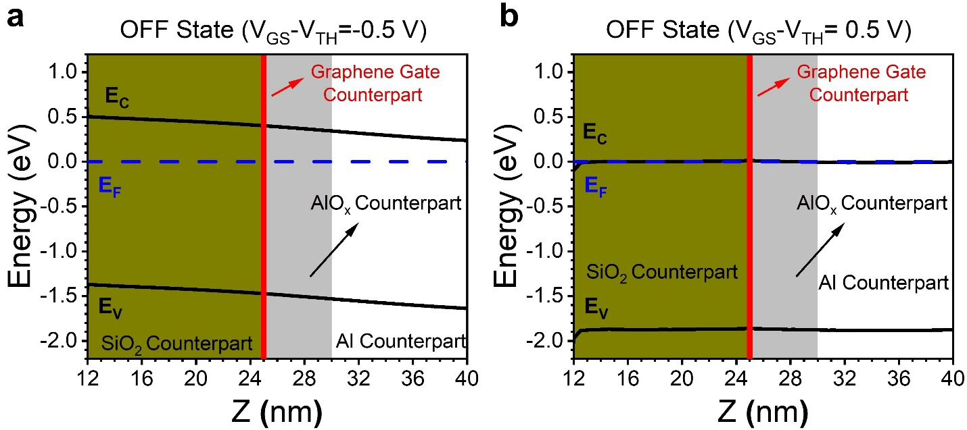

**Fig. S6.** Energy band diagrams of monolayer MoS2 along side-wall direction in the OFF (*V*GS - *V*TH =-0.5 V) and ON (*V*GS - *V*TH =1.5 V) states. The red line is the graphene gate counterpart region. (a) In the OFF state, the barrier blocks the carrier drifting from source to drain, thus the device turned off only with leakage current. (b) In the ON state, the whole channel is highly n-doped and the Fermi level is almost approaching the conduction band minimum, which leads to high ON state current.